Title: Environmental Monitoring

Introduction:

The IOT based Environmental Monitoring system This involves using sensors or other IoT devices to measure factors such as air quality, temperature, and humidity levels.

These connected IoT devices gather data about the environment and transmit it to a central hub. From here, the data can be reviewed in real-time or used for further analysis off line.

Project Definition:

The project involves setting up IoT devices to monitor environmental conditions in public parks, including temperature and humidity. The primary objective is to provide real-time environmental data to park visitors through a public platform, enabling them to plan their outdoor activities accordingly. This project includes defining objectives, designing the IoT sensor system, developing the environmental monitoring platform, and integrating them using IoT technology and Python.

Air Quality Management: These systems can measure pollutants like particulate matter, carbon monoxide, ozone, and nitrogen dioxide in urban areas, aiding in pollution control and public health efforts.

Climate Change Research: IoT devices can collect data on temperature, humidity, and greenhouse gas emissions to better understand and combat climate change.

Agriculture: Farmers use IoT-based monitoring to optimize crop growth by measuring soil moisture, temperature, and nutrient levels.

Industrial Applications: Industries can employ these systems to monitor emissions, optimize energy consumption, and ensure compliance with environmental regulations.

Disaster Management: IoT sensors can detect early warning signs of natural disasters such as earthquakes, floods, and wildfires, helping authorities respond more effectively.

SENSORS:

Water sesor:

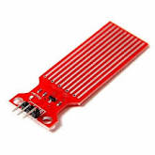

Environmental monitoring for water sensors is a critical aspect of managing and protecting our water resources. Water sensors are devices designed to detect and measure various parameters in water bodies, such as rivers, lakes, groundwater, and oceans. These sensors help collect data that can be used for various purposes, including assessing water quality, detecting pollution, and ensuring the safety of water sources.

Temperature sensor:

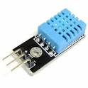

Environmental monitoring for a temperature sensor involves continuously measuring and recording temperature data in a particular area or system to ensure that temperature conditions remain within specified limits. This type of monitoring is crucial in various applications, such as industrial processes, agriculture, healthcare, and climate research.

Gas Sensor:

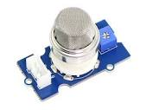Environmental monitoring using gas sensors involves the use of specialized sensors to detect and measure the concentration of various gases in the surrounding air or a specific environment. This type of monitoring is crucial for a wide range of applications, including air quality assessment, industrial safety, emissions control, and more.

Problem Statement :

Environmental monitoring is critical for ensuring the well-being of our planet and the health of its inhabitants. With increasing concerns about climate change, pollution, and natural disasters, there is a growing need for efficient and real-time monitoring of environmental parameters. The traditional methods of data collection and analysis are often time-consuming, expensive, and may not provide the required granularity and coverage.

To address these challenges, an Internet of Things (IoT)-based environmental monitoring system is proposed. The system aims to leverage IoT technologies to collect, transmit, and analyze environmental data from various sources in a cost-effective, scalable, and timely manner.

Key Problem Statements:

Data Collection and Integration: The diverse range of environmental parameters, such as air quality, water quality, temperature, humidity, and more, need to be collected from different sensors and sources. The challenge is to design a system that can seamlessly integrate data from various sensors and platforms, ensuring data accuracy and reliability.

Data Transmission and Connectivity: Establishing a reliable and secure communication network to transmit real-time data from remote monitoring sites to a central server is crucial. Connectivity issues, data loss, and data security concerns must be addressed.

Data Processing and Analysis: Once data is collected, it needs to be processed and analyzed to derive meaningful insights. Developing algorithms and models for data analysis that can detect trends, anomalies, and potential environmental threats is a significant challenge.

Energy Efficiency: Many remote environmental monitoring locations lack a stable power supply. Designing energy-efficient sensors and communication devices that can operate on low power sources or renewable energy is essential for long-term deployment.

Scalability and Adaptability: The system should be scalable to accommodate a growing number of sensors and environmental parameters. It should also be adaptable to changing environmental conditions and evolving sensor technologies.

Data Visualization and User Interface: Providing a user-friendly interface for stakeholders, such as environmental agencies, researchers, and the public, to access and interpret the data is crucial. Designing effective data visualization tools is a challenge.

Regulatory Compliance: Ensuring that the monitoring system complies with local and international environmental regulations and standards is vital. Navigating the regulatory landscape can be complex.

Data Security and Privacy: Protecting sensitive environmental data from unauthorized access and ensuring the privacy of individuals living in monitored areas is a significant concern.

Maintenance and Reliability: The monitoring system must be maintained regularly to ensure its reliability. Remote locations can pose challenges in terms of accessing and servicing the sensors and communication infrastructure.

Cost-Effectiveness: Developing an IoT-based environmental monitoring system that is cost-effective, both in terms of initial setup and ongoing operational expenses, is critical for widespread adoption.

Addressing these problem statements is essential for the successful implementation of an IoT-based environmental monitoring system, which can provide valuable insights, support policy decisions, and contribute to a healthier and more sustainable planet.

IOT sensor Design:

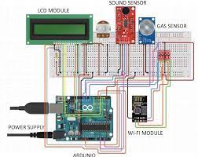

Diagram:

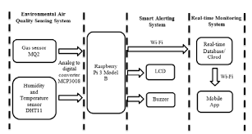

Flow Chat:

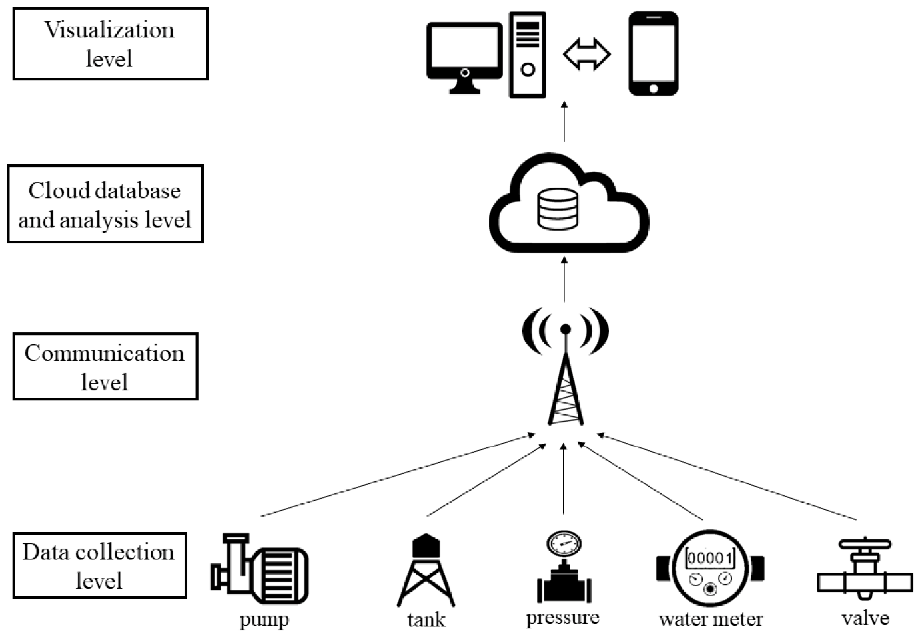

Purpose :

An Internet of Things (IoT)-based environmental monitoring system serves several important purposes, leveraging interconnected devices and sensors to collect and transmit data related to the environment. These systems have a wide range of applications across various sectors, and their purposes include:

Real-time Data Collection: IoT environmental monitoring systems enable the continuous and real-time collection of data related to environmental parameters, such as temperature, humidity, air quality, water quality, soil conditions, and more. This data provides an up-to-date picture of the environment's status.

Data Accuracy: By utilizing sensors and automated data collection, IoT systems offer high accuracy and precision in environmental data, reducing human error and improving the reliability of information.

Early Warning and Alerts: These systems can trigger alerts and notifications when environmental parameters deviate from predefined thresholds. This early warning system is crucial for responding to emergencies, such as natural disasters, industrial accidents, or environmental pollution.

Remote Monitoring: IoT-based systems allow for remote monitoring of environmental conditions, which is particularly valuable in remote or hazardous locations where human presence may be limited or risky.

Predictive Analysis: By collecting historical data, IoT environmental monitoring systems can facilitate predictive analysis and modeling. This can help anticipate environmental changes or trends, aiding in decision-making and resource planning.

Resource Management: In agriculture and forestry, IoT systems can optimize resource management by providing data on soil moisture, temperature, and weather conditions, helping farmers make informed decisions about irrigation and planting.

Energy Efficiency: IoT environmental sensors can be integrated into building management systems to monitor and control heating, ventilation, and air conditioning (HVAC) systems, optimizing energy usage for greater efficiency.

Health and Safety: In industrial settings, these systems can monitor air quality, temperature, and humidity to ensure worker safety and compliance with regulatory standards.

Environmental Compliance: For businesses and industries, IoT environmental monitoring helps ensure compliance with environmental regulations by continuously tracking emissions, water quality, and other relevant factors.

Research and Conservation: Researchers and conservationists use IoT-based systems to collect data in natural ecosystems, helping them study wildlife behavior, monitor climate change impacts, and protect endangered species.

Smart Cities: In urban areas, IoT environmental monitoring contributes to the development of smart cities. It aids in traffic management, waste management, noise pollution control, and efficient energy usage.

Disaster Preparedness and Response: IoT systems are instrumental in disaster management, providing essential data for early warning systems, tracking the movement of natural disasters (e.g., hurricanes, floods), and coordinating emergency response efforts.

Cost Savings: By optimizing resource usage, reducing waste, and preventing costly environmental incidents, IoT-based environmental monitoring can lead to significant cost savings for organizations and governments.

Data Transparency: Many IoT-based environmental monitoring systems offer publicly accessible data, increasing transparency and public awareness of environmental conditions.

Environmental Conservation: Ultimately, the purpose of IoT environmental monitoring is to contribute to the conservation and protection of the environment by providing the necessary data for informed decision-making and sustainable practices.

In summary, IoT-based environmental monitoring systems serve a wide range of purposes, from ensuring safety and compliance to optimizing resource usage, promoting sustainability, and facilitating scientific research. They play a critical role in addressing environmental challenges and improving our understanding of the world around us.

Application:

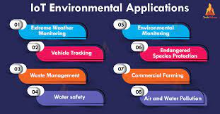

Conclusion:

IoT-based environmental monitoring systems are revolutionizing the way we gather and utilize environmental data. They have the potential to greatly enhance our ability to protect and preserve our natural resources, respond to environmental challenges, and make informed decisions for a more sustainable future. However, to fully realize these benefits, it is essential to address the associated challenges and ensure responsible and ethical use of IoT technologies in environmental monitoring.